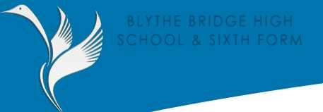
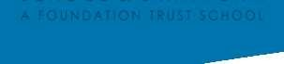
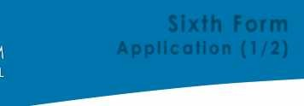
SECTION A – PERSONAL DETAILS
Surname | Forename(s)
Address | Name of Parent(s)/Guardian(s)
Postcode | Contact Number
Telephone | Mobile Number
Date of Birth

The course options available at Blythe Bridge High School and Sixth Form are outlined in the online prospectus on the Sixth Form webpage. A printable copy is available. Please complete this form using the online prospectus and information from the Sixth Form evening. The deadline for completing the application is 6th December 2019.

SECTION B – EDUCATION & QUALIFICATIONS
Examinations you have taken or are taking and grades achieved. Please indicate if a mock result.

SUBJECT | GRADE/RESULT | DATE ACHIEVED
EXAMPLE: GCSE - Maths | 8 | May 2019/20

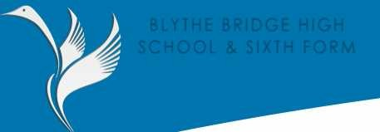
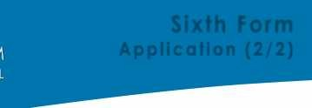
SECTION C – COURSE OPTIONS
Please list below the subjects/courses you are applying for in priority order.
1st Course/Subject
2nd Course/Subject
3rd Course/Subject

Reasons for choice of Subject/Course. Please support your application by explaining choices.

What is your goal immediately after the Sixth Form (if known).

What is your long term goal/career idea (if known)

Have you had an interview with a Careers Advisor? (Please Tick)

Year 9 | Yes |  | Year 10 | Yes |  | Year 11 | Yes
 | No |  |  | No |  |  | No
 | Don’t Know |  |  | Don’t Know |  |  | Don’t Know

SECTION D – CURRENT SCHOOL

Current School

Address

Name Of Referee

FOR OFFICE USE ONLY
Received | Acknowledged
Interview | Offer Sent
Notes

